**Experiment No. 04**

**1. Problem Statement:** A multiple-input multiple-output (MIMO) channel is equipped with n**T** transmitting antennas and n**R** receiving antennas.

**(a) Investigate the effect** of transmitting antennas on the channel capacity of MIMO channel.

**(b) Investigate the effect** of receiving antennas on the channel capacity of MIMO channel.

**2. Derivation of the channel capacity** **for MIMO channel**

Let,

$P_{T}$**=** Transmit power

$N_{0}$**=** Noise power

$n_{T}$**=** Number of Antennas at the transmitter

$n_{R}$**=** Number of Antennas at the Receiver

$I_{nR}$**=** Identity Matrix

Required formula for the derivation of the capacity are -

${(A+B)}^{†}= A^{†}+ B^{†}$…… (1)

${(AB)}^{†}=B^{†}A^{†}$

𝐸[𝒙 $z^{†}$] = 0 …… (2)

Since x and z are independent,

𝐸(𝑨+𝑩) = 𝐸(𝑨)+𝐸(𝑩) …… (3)

*det*(𝛼𝑨) = $α^{n}$*det*(𝑨), 𝑛 = 𝑚𝑎𝑡𝑟𝑖𝑥 𝑜𝑟𝑑𝑒𝑟

**(i) Covariance of Transmit Signal:**

𝑹𝒙 **= 𝐸[$xx^{†}$] = $\frac{P_{T}}{n_{T}}I_{nT}$**

**(ii) Covariance of Noise Signal:**

𝑹***z*** **= 𝐸[$zz^{†}$] = ${N_{0}I}_{nR}$**

**(iii) Covariance of Received Signal:**

𝑹*y* = 𝐸[${yy}^{†}$] = 𝐸[(𝑯𝒙+𝒛) ${(Hx+z)}^{†}$]

= 𝐸[(𝑯𝒙+𝒛){${(Hx)}^{†}$ + ${(z)}^{†}$}]

= 𝐸[(𝑯𝒙+𝑧){${(x}^{†}H^{†}$ + $z^{†}$}]

= 𝐸[${(Hxx}^{†}H^{†}$ + ${Hxz}^{†}$ + ${zx}^{†}H^{†}$ + ${zz}^{†})$]

= 𝐸 ${[Hxx}^{†}H^{†}]$ + 𝐸 ${[Hxz}^{†}]$ + 𝐸 ${[zx}^{†}H^{†}]$ + 𝐸 ${[zz}^{†}]$

= 𝐸 ${[Hxx}^{†}H^{†}]$ + 𝐸 ${[zz}^{†}]$

= *H*𝐸 ${[xx}^{†}H^{†}]$ + 𝐸 ${[zz}^{†}]$

= *H* {$\frac{P_{T}}{n_{T}}I_{nT}$} $H^{†}$ + ${N_{0}I}_{nR}$

𝑹*y* = {} + which is the received signal covariance.

**(iv) Entropy of Noise Signal:**

𝑯(𝒛) = $\log_{2}det$ (𝜋𝑒𝑹*z*) =(𝜋𝑒 ${N_{0}I}_{nR}$)

**(v) Entropy of Received Signal:**

𝑯(𝒚)= $\log_{2}det$ (𝜋𝑒𝑹*y*) = {𝜋𝑒( $\frac{P_{T}}{n_{T}}$ {${HH}^{†}$}+ ${N_{0}I}_{nR}$)}

**(vi) Mutual Information:**

𝐼(𝒙;𝒚)=𝑯(𝒚)−𝑯(𝒛) = $\log_{2}det$ (𝜋𝑒𝑹𝒚)− $\log_{2}det$ (𝜋𝑒𝑹𝒛)

= $\log_{2}\frac{det(πeRy)}{det(πeRz)}$

= $\log_{2}\frac{det⁡\{πe(\frac{P_{T}}{n_{T}}\{HH^{†}\} + {N_{0}I}_{nR})\}}{det(πe{N_{0}I}_{nR})}$

= $\log_{2}\frac{{(πeN_{0})}^{n_{R }}det⁡\{(\frac{P_{T}}{n_{T}}\{HH^{†}\} + I_{nR})\}}{{(πeN_{0})}^{n_{R }}det(I_{n_{R}})}$

= $\log_{2}\frac{det⁡\{(\frac{P_{T}}{{n_{T}N}_{0}}\{HH^{†}\} + {N_{0}I}_{nR})\}}{1}$

𝐼(𝒙;𝒚) = $\log_{2}det⁡\{(\frac{P_{T}}{{n_{T}N}_{0}}\{HH^{†}\} + {N_{0}I}_{nR})\}$, which is the Mutual Information.

**(vii) Capacity at the Receiver:**

*C = ${}_{Q}^{max}{ I\left(x;y\right)= {}_{Q}^{max}{ \log_{2}det⁡\{(\frac{P_{T}}{{n_{T}N}_{0}}\{HH^{†}\} + {N_{0}I}_{nR})\} }}$*

*C = $\log_{2}det⁡\{(\frac{P_{T}}{{n_{T}N}_{0}}\{HH^{†}\} + {N_{0}I}_{nR})\}$*, which is the channel capacity.

**3. Program for the channel capacity for MIMO channel**

* **MATLAB Code for plotting the capacity**

% Ergodic Capacity of Nr x Nt fading MIMO Channel with

% no channel knowledge at the transmitter.

clc

clear all;

%%%%%%%% Initialization %%%%%%%%

N=30000; % Number of Iterations for H

No=1; % Noise Variance

%%%%%%%% Number of antennas %%%%%%%%

nt=2; % Number of Transmit antennas

nr=2; % Number of Receive antennas

%%%%%%%% Correlation of antennas %%%%%%%%

rhot=0; % Correlation coefficient (Transmitter)

rhor=0; % Correlation coefficient (Receiver)

Rt=ExponencorrMrtx(nt,rhot); % Correlation Matrix Rt

Rr=ExponencorrMrtx(nr,rhot); % Correlation Matrix Rr

%%%%%%%% SNR of Channel %%%%%%%%

SNRdB=[0:1:15]; % Signal-to-Noise Ratio

l=length (SNRdB);

SNR=zeros(1,l);

%%%%%%%% Creation of SNR from 1 to L %%%%%%%%

for i=1:l

SNR(i)=10^(0.1*SNRdB(i)); %Conversion of SNR in magnitude form

P(i)=SNR(i)*No;

end

%%%%%%%% Calculation of Ergodic capacity %%%%%%%%

Erg_Cap_unknown=zeros(1,l);

for i=1:l % Loop of SNR

C_unknown=zeros(1,N);

%%%%%%%% Calculation of capacity %%%%%%%%

for j=1:N

H=CGM (nr,nt,Rr,Rt); % Generate Rayleigh Distributed fading

C_unknown(j)=log(det(eye(nr)+(SNR(i)/nt)*(H*H')));

end

%%%%%%%% Ergodic Capacity %%%%%%%%

Erg_Cap_unknown(i)=mean(C_unknown); %Ergodic multicast capacity with no CSIT

%%%%%%%% Printing Data %%%%%%%%

fprintf ('% e\t% e \n',SNRdB(i),Erg_Cap_unknown(i));

end

%%%% Plotting of Ergodic capacity versus SNR %%%%

plot (SNRdB,Erg_Cap_unknown,':r*')

xlabel ('SNR (dB)');

ylabel ('Ergodic capacity (bits/sec/Hz)');

title ('Ergodic capacity versus SNR');

grid on

hold on

* **To build n*n identity matrix the user defined function**

function out=ExponencorrMrtx(n,rho);

% generate an nxn exponential correlation matrix

A=ones(n);

for i=1:n

for j=1:n

if i==j

A(i,j)=1;

end

if i>j

A(i,j)=rho^(i-j);

else A(i,j)=rho^(j-i);

end

end

end

out=A;

* **To generate relay distributed fading user defined function**

function out=CGM(nr,nt,Rr,Rt)

% Generate Complex Gaussian matrix

X = sqrt(0.5)*randn(nr,nt)+i*sqrt(0.5)*randn(nr,nt);

out=Rr^(1/2)*X*Rt^(1/2);

**4. Numerical results of the MIMO channel**

**(a) Numerical data for measuring capacity at different SNR (dB)**

|  |  |  |  |
| --- | --- | --- | --- |
| **SNR (dB)** | **Capacity(bits/sec/Hz)** | **SNR (dB)** | **Capacity(bits/sec/Hz)** |
| 0 | 1.169220 | 8 | 3.178715 |
| 1 | 1.353969 | 9 | 3.518419 |
| 2 | 1.558950 | 10 | 3.840310 |
| 3 | 1.781360 | 11 | 4.206453 |
| 4 | 2.034536 | 12 | 4.573855 |
| 5 | 2.297278 | 13 | 4.936794 |
| 6 | 2.571197 | 14 | 5.333823 |
| 7 | 2.861399 | 15 | 5.720873 |

**5. Effects of transmitting antennas**

* **Graphical representation**

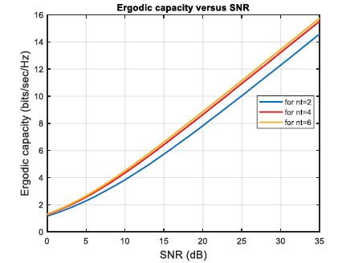

**Figure 4.1:** Variation of capacity with respect to SNR for Nt = 2, nt = 4, Nt = 6 taking nr = 4.

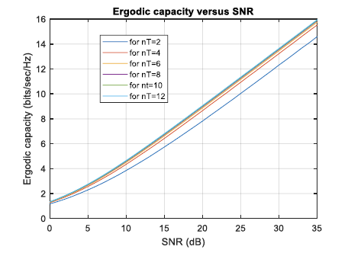

**Figure 4.2:** Effect on capacity by increasing the number of antennas at transmitter side taking number of receiving antenna constant at nR=2.

**6. Effects of receiving antennas**

* **Graphical representation**

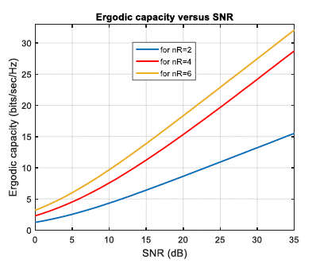

**Figure 4.3:** Variation of capacity with respect to SNR for nR=2, nR=4, nR=6 taking nT=4.

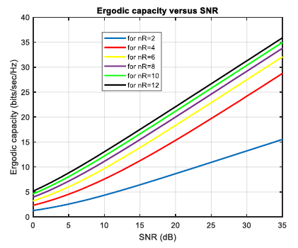

**Figure 4.4:** Effect on capacity by increasing the number of antennas at the receiver side.

**7. Combined effect**

* **Graphical representation**

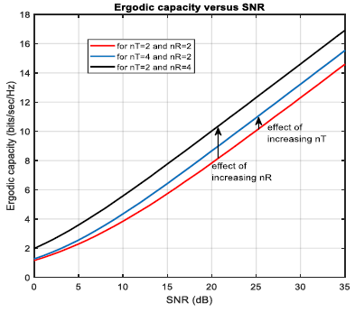

**Figure 4.5:** Variation of capacity by separately the receiving antenna and transmitting antenna.

**8. Discussion and Conclusion**

**a) Discussion:** All of the figures depict the variation in capacity caused by adjusting the number of antennas on both the receiver side and the receiver side. Some graphs are drawn with the number of receiving antennas fixed and the number of broadcasting antennas variable, or vice versa. Figure 4.5 depicts the effect of increasing the sending antenna while keeping the receiving antenna the same size on capacity. It demonstrates that receiving antennas have a bigger influence than emitting antennas.

**b) Conclusion:** From our investigation, we can draw the following conclusions:

* We have generated a graph of capacity versus SNR, which is dependent on noise. Power. Because there is no noise power at the transmitter end, SNR is quite high. The number of antennas at the transmitter end can be changed to alter the noise effect but not the capacity. As a result, the number of the transmitting antenna has a minor impact on capacity.
* As we all know, increasing the number of receiving antennas creates multiple pathways for the signal to reach the receiver, and there is a variation in encountering different SNR values. However, the receiver produces an output with the highest SNR or the lowest error. As a result, capacity grows. As a result, the number of receiving antennas has a considerable impact on any channel's capacity.

Finally, comprehending the statistical features of the MIMO channel as revealed by the ergodic capacity analyses is critical for building robust and efficient digital communication systems.